The Parish Church of St Andrew
Orford with Longford

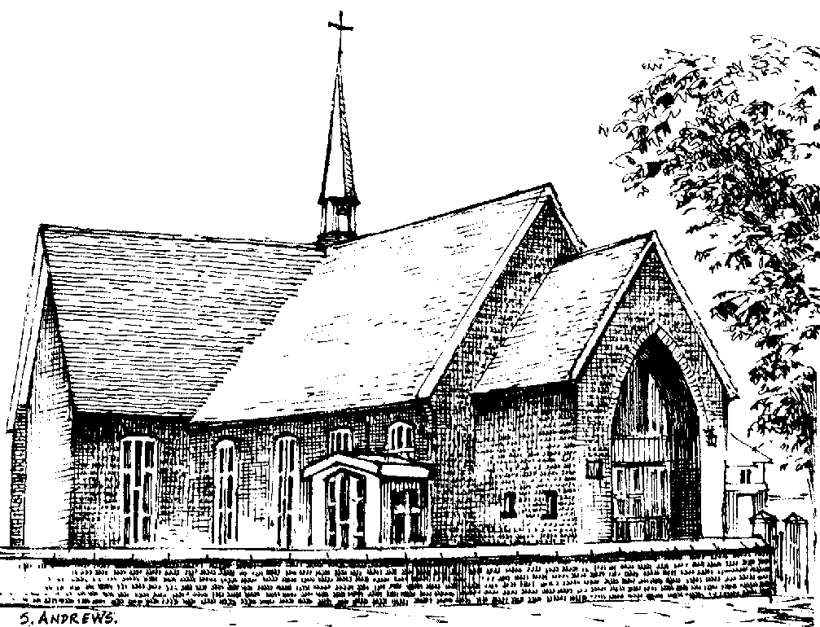

Linda Walsh
1961 - 2006

Thursday 16th November 2006

Order of Service

ALL STAND as the funeral procession enters the church. Once the family are seated, please SIT.

The Priest may read one or more scriptural sentences.

Introduction

Priest: We meet in the name of Jesus Christ, who died and was raised to the glory of God the Father. Grace and mercy be with you.
All: Amen.

The priest introduces the service

Priest: Let us pray:

Almighty God, you judge us with infinite mercy and justice, and love everything you have made. In your mercy turn the darkness of death into the dawn of new life, and the sorrow of parting into the joy of heaven; through our Saviour, Jesus Christ. Amen

All: Merciful Father, hear our prayers and comfort us; renew our trust in your Son, whom you raised from the dead; strengthen our faith that all who have died in the love of Christ will share in his resurrection; who lives and reigns with you, in the unity of the Holy Spirit, one God, now and for ever. Amen

The Ministry of the Word

Hymn: “The Lord’s my shepherd” (please stand)

The Lord's my Shepherd, I'll not want;
he makes me down to lie -
in pastures green; he leadeth me -
the quiet waters by.

My soul he doth restore again,
and me to walk doth make -
within the paths of righteousness,
e'en for his own name's sake.
Yea, though I walk through death's dark vale,
yet will I fear no ill;
for thou art with me, and thy rod -
and staff me comfort still.

My table thou hast furnished
in presence of my foes;
my head thou dost with oil anoint ,
and my cup overflows.

Goodness and mercy all my life
shall surely follow me;
and in God's house, for evermore
my dwelling place shall be.

The Scriptural Reading

A reading from the gospel according to St John (John 14. 1-6)

Jesus said, "Do not let your hearts be troubled. Trust in God; trust also in me. In my Father's house are many rooms; if it were not so, I would have told you. I am going there to prepare a place for you. And if I go and prepare a place for you, I will come back and take you to be with me that you also may be where I am. You know the way to the place where I am going."
Thomas said to him, "Lord, we don't know where you are going, so how can we know the way?"
Jesus answered, "I am the way and the truth and the life. No one comes to the Father except through me.

This is the word of the Lord
All: Thanks be to God

A Poem

The Address

“I watch the sunrise” recorded and sung by children from St Andrew’s School, accompanied by Mr Allen

The Prayers:

Priest: God of mercy, Lord of life, you have made us in your image to reflect your truth and light: we give you thanks for Linda, for the grace and mercy she received from you, for all that was good in her life, and especially for the memories we treasure today.

Lord, in your mercy
All: hear our prayer.

Priest: You promised eternal life to those who believe. Remember for good this your servant Linda as we also remember her. Bring all who rest in Christ, including Sheila and those we bring to mind this morning, into the fullness of your kingdom where sins have been forgiven and death is no more.

Lord, in your mercy
All: hear our prayer.

Priest: Your mighty power brings joy out of grief and life out of death. Look in mercy on Jim and Rachel, Jim and Linda’s families, and all who mourn at this time. Give them patient faith in times of darkness. Strengthen them with the knowledge of your love.

Lord, in your mercy
All: hear our prayer.

Priest: Father, you are tender towards your children and your mercy is over all your works. Heal the memories of hurt and failure. Give us the wisdom and grace to use aright the time that is left to us here on earth, to turn to Christ and follow in his steps in the way that leads to everlasting life.

Lord, in your mercy
All: hear our prayer.

God of mercy, entrusting into your hands all that you have made and rejoicing in our communion with all your faithful people, we make our prayers through Jesus Christ our Saviour. Amen.

Priest: Let us pray with confidence as our Saviour has taught us
All: Our Father, who art in heaven, hallowed be thy name; thy kingdom come; thy will be done; on earth as it is in heaven. Give us this day our daily bread. And forgive us our trespasses, as we forgive those who trespass against us. And lead us not into temptation; but deliver us from evil. For thine is the kingdom, the power and the glory, for ever and ever. Amen.

Hymn: “All things bright and beautiful”

All things bright and beautiful,
all creatures great and small,
all things wise and wonderful,
the Lord God made them all.

Each little flower that opens,
each little bird that sings,
he made their glowing colours,
he made their tiny wings:

The purple headed mountain,
the river running by,
the sunset, and the morning
that brightens up the sky:

The cold wind in the winter,
the pleasant summer sun,
the ripe fruit in the garden,
he made them every one:

He gave us eyes to see them,
and lips that we might tell
how great is God almighty,
who has made all things well:

All things bright and beautiful,
all creatures great and small,
all things wise and wonderful,
the Lord God made them all.

Commendation and Farewell [please remain standing]

Priest: Let us commend Linda to the mercy of God our Maker and Redeemer.

The coffin is sprinkled with holy water taken from the font

Priest: With this water we call to mind Linda’s baptism. As Christ went through the deep waters of death for us, so may he bring us to the fullness of resurrection life with Linda and all the redeemed.

God our creator and redeemer, by your power Christ conquered death and entered into glory. Confident of his victory and claiming his promises, we entrust Linda to your mercy in the name of Jesus our Lord, who died and is alive and reigns with you, now and for ever. Amen

All: Heavenly Father, in your Son Jesus Christ you have given us a true faith and a sure hope. Strengthen this faith and hope in us all our days, that we may live as those who believe in the communion of saints, the forgiveness of sins and the resurrection to eternal life; through Jesus Christ our Lord. Amen.

Priest: May God, in his infinite love and mercy, bring the whole Church, living and departed in the Lord Jesus, to a joyful resurrection, and the fulfilment of his eternal kingdom. Amen.

As the procession leaves church, the Nunc Dimittis is read. Please follow the family.

The Committal follows the service in Church, and will take place at Walton Lea crematorium at 12.30pm. Everyone who wishes is invited to join the family at St Benedict’s Club, Rhodes Street, after the service.

The Committal

Opening sentence and introduction:

Words from Psalm 121:

I lift up my eyes to the hills:
but where shall I find help?
Our help comes from the Lord:
who has made heaven and earth.

A prayer for Linda: Remember O Lord your servant Linda who has gone before us with the sign of faith, and now rests in the sleep of peace. According to your promises, grant to her and to all who rest in Christ, refreshment, light and peace; through the same Jesus Christ our Lord. Amen

The Committal: We have entrusted our sister Linda to God's mercy, and we now commit her body to be cremated: in sure and certain hope of the resurrection to eternal life through our Lord Jesus Christ, who died, was buried, and rose again for us. To him be glory for ever. Amen

A prayer for Linda’s family and friends: Almighty God, Father of all mercies and giver of all comfort: deal graciously, we pray, with those who mourn, that casting all their care on you, they may know the consolation of your love; through Jesus Christ our Lord. Amen

The Blessing: May God give you his comfort and his peace, his light and his joy, in this world and the next; and the blessing of God almighty, the Father, the Son, and the Holy Spirit, be among you and remain with you always. Amen


Acknowledgement: Common Worship: Pastoral Services, material from which is included in this service, is copyright © The Archbishops’ Council (2000-2002)

